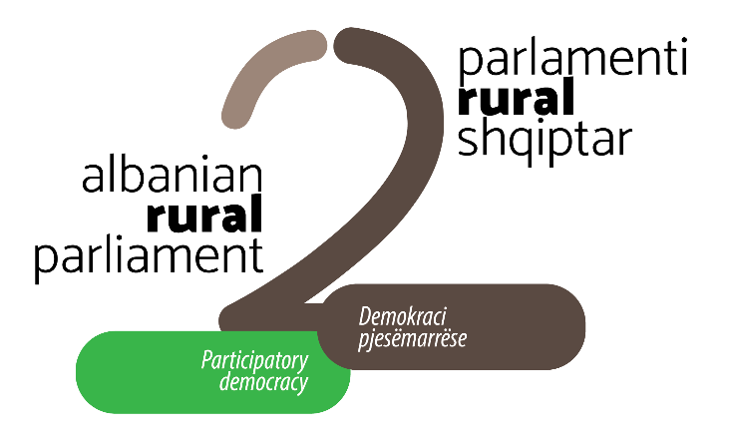

In the framework of
the 2nd ALBANIAN RURAL PARLIAMENT
that will take place on April 2-3, 2020 at the premises of the Agriculture University of Tirana

Albanian Network for Rural Development organizes
DRINI REGION RURAL FORUM
(Including qarks of Shkodër, Lezhë and Kukës)
March 5 - 6, 2020
At “Junik” sh.p.k, Lezhë
(SMT area, near Lezha Forest Service Directory)

ALBANIAN RURAL PARLIAMENT II 2020|EUROPEAN PERSPECTIVE OF RURAL ALBANIA
Albanian Rural Parliament (ARP) is an initiative of the Albanian Network for Rural Development (ANRD) and represents a platform of advocacy, capacity building and networking dedicated to rural development. Albanian Rural Parliament is part of the pan-European rural movement aiming at the welfare of rural residents (https://anrd.al/rural-albanian-parliament/)
The platform of the Albanian Rural Parliament is an inclusive practice that aims to influence and accelerate the reform processes in the rural sector for revitalization of rural communities. Following the Albanian Rural Parliament (September 2017) and, in response to the current challenges of agricultural and rural development in Albania, the ANRD in cooperation with the Agricultural University of Tirana (AUT) are organizing the second Albanian Rural Parliament on April 2 - 3 2020.

The 2nd Albanian Rural Parliament - a decentralized platform - will be organized following four regional rural forums concluding stakeholder advocacy efforts at all levels.

- Drini Region Rural Forum – Lezhë, 5-6 mars 2020
- Arber Region Rural Forum
- Egnatia Region Rural Forum
- Vjosa Region Rural Forum
- ALBANIAN RURAL PARLIAMENT II April 2-3, 2020, in Tirana

DRINI REGION RURAL FORUM |Lezhë, March 5-6, 2020
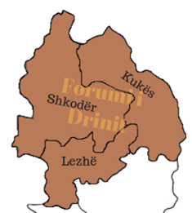
Drini Region Rural Forum takes place in the framework of the 2nd Albanian Rural Parliament. The one-day rural forum aims to bring together representatives of public institutions and civil society, grass-root organizations, farmers and producers’ associations, women and rural youth groups, active citizens and others interested in influencing the national rural agenda to reflect needs, priorities and the interests of local actors and rural communities in the Drini region, namely the regions of Shkodra, Lezha and Kukës.

Drini Region Rural Forum will create opportunities for rural development actors to connect to the decision-making and policy-making processes of the agriculture and rural sector. The forum aims to encourage debate on the regional development challenges, to provide space for consultation on the agrarian and rural policies and strategies, as well as to orient stakeholders on concrete actions towards sustainable development of rural communities.
PROGRAM OF DRINI REGION RURAL FORUM | Lezhë, 5-6 March 2020
DAY I: THURSDAY 5 MARCH 2020
From 15:00 | Arrival of participants from remote communities of Kukës and Shkodër qarks  Accommodation in the hotel
18:00 – 19:00 | Welcoming ceremony

DAY II: FRIDAY 6 MARCH 2020
09:00 | Registration of participants  Welcoming coffee
10:00 | Welcome address  Sabah Djaloshi, Member of ANRD board, Executive Director of Agro Puka  Pjerin Ndreu, Mayor of Lezha Municipality
10:20 – 12:10 | Plenary Session: Drini region development challenges and national and European agrarian and rural development policies  Moderator: Evelina Azizaj, ANRD National Coordinator  Representative of Ministry of Agriculture and Rural Development (tbc)  Linda Maci, Representative of Lezhë Regional Council (tbc)  Shpëtim Quku, Representative of Albanian Development Fund (tbc)  Mustaf Kopani – Vice-Mayor of Pukë Municipality (tbc)  Anna Carboni, Representative of VIS Albania  Gent Imeraj, Representative of ANRD Rural Youth Hub
12:10 – 12:30 | The reality and future of rural communities in the region: 'food for thought'  Keynote speaker: Gjergj Leqejza  Potential for tourism sustainable development as a catalyst for  inclusive socio-economic development of rural communities (tbc)
12:30 – 13:30 | Lunch break
13:30 – 15:00 | Workshop 1: Public consultation on the new Cross-cutting Strategy of Agriculture and Rural Development - a turning point in the participatory design of rural strategies  Moderators: Evelina Azizaj&Vitor Malutaj  Workshop 2: Municipalities and their role in the sustainable development of rural communities  Moderators: Fatmir Guri&Lorena Totoni  Workshop 3: the reality of young people in rural areas amidst challenges and aspirations for the future  Moderators: Juljan Papaproko&Gent Imeraj
15:00 | Plenary Session: Get the LEADER approach up and running in Albania - activating and supporting local leadership  Moderatator: Evelina Azizaj  Mirjeta Gjongecaj, Coordinator of LAG “Bjeshkët e Nëmuna”  Selim Lisha, Coordinator of LAG “Pashtriku”  Astrit Hyseni, Coordinator of LAG “Puka”  Drita Tanazi, Representative of Consorcium “Fryma e Kelmendit”  Rigerta Loku, Leader for setting up LAG “Mirdita”  Petrit Imeraj, Leader for setting up LAG “Jezerca”
16: 30 | Conclusions and closure of Drini Region Rural Forum

