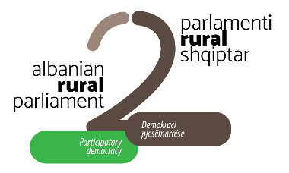

This project is funded
by the European Union

INVITATION

Dear Sir/Madam,

Albanian Network for Rural Development (ANRD) is pleased to invite you to the Drini Region Rural Forum, to be organized on Friday, March 6th, 2020, from 9:00 am to 17:00 pm at the premises of Junik sh.p.k, Lezha town.
Drini Region Rural Forum takes place in the framework of the 2nd Albanian Rural Parliament (April 2-3, 2020) and, in response to the current challenges of agricultural and rural development in the region, including qarks of Shkodër, Lezhë and Kukës.

The one-day rural forum aims to bring together representatives of public institutions and civil society, grass-root organizations, farmers and producers’ associations, women and rural youth groups, active citizens and others interested in influencing the national rural agenda to reflect needs, priorities and the interests of local actors and rural communities in the Drini region, namely the regions of Shkodra, Lezha and Kukës.

Kindly confirm your attendance by January March 02, 17:00, 17:00, at the following e-mail addresses: info@anrd.al; info@agropuka.org.
We look forward seeing you there!

